

ST. RAPHAEL EXAMINATION BOARD
TERM ONE EXAMINATIONS 2024
PRIMARY SEVEN
ENGLISH LANGUAGE SET IV
Time allowed: 2 hours 15 minutes

INDEX NO.

CANDIDATE’S NAME:…………………………………………………………………………………………………………………………………….

CANDIDATE’S SIGNITURE:………………………………………………………………………………………………………………………….

DISTRCT:……………………………………………………………………………………………………………………………………………………………

Read and follow these instructions carefully:

1. The paper has two sections: A and B.
FOR EXAMINERS USE ONLY
QN. NUMBER | MARKS | EXAMINER’S  INITIAL
1-10
11-20
21-30
31-40
41-43
44-46
47-49
50-52
53-55
TOTAL

2. Section A has 50 questions (50marks)

3. Section B has 5 questions (50marks)

4. Answer ALL questions. All answers to both Sections A and B must be written in the spaces provided.

5. All answers must be written using a blue or black ball point pen or ink.

6. Diagrams should be drawn in pencil.

7. Unnecessary crossing of work may lead to loss of marks.

8. Any handwriting that cannot be easily read may lead to loss of marks.

9. Do not fill anything in the boxes indicated;
For Examiner’s use only.

Turn over
SECTION A:

For each of the questions 1 to 5, fill in the blank space with a suitable word.
1. The teacher is looking _his red pen.

2. Opondo has reading a storybook for two hours now.

3. She wrote the letters all by .

4. you come early, you won’t sit the examination.

5. January is the month of the year while February is the second.

For each of the questions 6 to 15, use the correct form of the word given in the brackets to complete the sentence.
6. Why does that man behave in a _way? (child)

7. Jerome’s composition had an interesting _(conclude)

8. A lake is than a river. (deep)

9. Where have you _your dictionary? (keep)

10. The conference room was decorated. (pretty)

11. The _has very beautiful pics. (photograph)

12. Paul likes attending marriages. (tradition)

13. The bird entered the house through the _window pane. (break)

14. The supervisor spoke so that we all understood his instructions. (loud)
15. The boy who hurt both his is receiving treatment. (foot)

In numbers 16 – 18, arrange the words in ABC order.
16. library, blackboard, chalkboard, erosion

17. deep, dip, debt, depth

18. anthill, black, ant, antonym

In numbers 19 and 20, write a sentence using the words below.
19. fare

20. fair

In numbers 21 and 22, give the plural of the following words.

21. fish

22. hoof

For numbers 23 and 24, arrange the words to form correct sentences.
23. here from far not is home Our.

24. wood used cutting saw a for Is?

In numbers 25 and 26, write in full.
25. Hon
26. e.g. In numbers 27 and 28, rewrite each sentence giving a single word for the underlined group of words.
27. Today’s debaters were not co-operative.

28. We talked to our teachers in a polite way.

In questions 29 and 30, rewrite each sentence giving the opposite of the underlined word.
29. My half – sister is a very obedient girl.

30. The more enemies you get, the more security you may require.
SUB SECTION II
For questions 31-50, follow the instructions given in brackets.
31. The juice is very cold. It is like ice. (Rewrite using …….as………….as…….)

32. There was some charcoal in the kitchen. (Rewrite using …….any ……………)

33. The weather was too hot for us to sit outside. (Write as two separate
sentences)

34. The nurse tried to help me but she failed. (Begin: Although…………………..)

35. All the children are not smart today. (Begin: Every …………………….)

36. Celine is a journalist. I travelled with her to Soroti.
(Join as one using: ……………with whom…………)

37. The reverend preached before praying. (Rewrite using: ……..after…………)

38. Derrick has been troubled since first term. Derrick has repented all his sins.
(Use …………………………………..……because …………………………………..)

39. Marion is very creative. She scored the first goal for the lion house.
(Use:……...so ………that…………………….)

40. If you bake tasty cakes. I will buy them. (Use …………would…………..)

41. The taxi carries passengers. The taxi carries luggage. (Join using: …..not
only………….…)

42. Benna has an expensive pair of shoes. (Begin: What ………………!)
43. Lindo mopped our classroom. (Rewrite ending:………………….mopped?)

44. The P.2 pupils washed the plates last night. (Begin: The plates ……………..)

45. The sewing machine broke down immediately the customer arrived.
(Use ………………………..……..as soon as………………………….……)

46. The gardener was planting seeds. The hunters were chasing an antelope.
(Use ………………………..……..while ………………….…………..)

47. Mother was not at home. Father was not at home. (Begin: Both…………)

48. You should not drink and drive. (Rewrite using ………..…….mustn’t………..)

49. “Will you order a drink at the hotel?” Edwin asked Paulo.
(Begin: Edwin asked Paulo………………………….)

50. Nankya is not as thin as Gloria. (Rewrite the sentence using……….than……)

SECTION B
51. Read the passage below and answer questions in full sentences.

Ann wanted to go over to Ethel’s house to play but Ann’s mother refused her because she needed to watch over her baby sister Prim. Prim had just learnt to walk and therefore she needed someone to take care of her.
Although Ann requested her mother to let her go to her friend’s house to play, Ann’s mother refused. She instead instructed Ann to watch over her sister with great care. Ann’s mother was tired. She had been watching Prim all day long. “You have to watch Prim because I have to take a bubble bath,” Ann’s mother said. So she went into the bathroom.
While the mother was enjoying the bubble bath, Ann was busy watching her sister taking all the clothes out of every drawer in the room. She watched her take all the rice, salt, flour, sugar and coffee out of the kitchen cupboard and spill it all on the nice clean floor. She also watched her pull the table cloth off the kitchen table. The bananas that had been on the table landed on Prim’s head.
Ann watched Prim crying very loudly attracting the mother to get out of the bathroom. “What is going on?” she asked Ann angrily, “I told you to watch Prim!” Ann replied truthfully, “Mummy, I was watching her all the time because that’s what you told me to do.”

(a) Where did Ann want to go?
Questions

(b) What was the name of Ann’s friend?

(c) Who is Ann’s baby sister?

(d) Why did Ann’s mother refuse Ann to go out of the house?

(e) What did Ann do when the mother was away?

(f) What kind of bath did Ann’s mother have?

(g) Where were the kitchen items kept according to the story?

(h) What did Ann’s sister take out of the kitchen cupboard?

(i) What mistake did Ann make?

(j) Suggest a suitable title for this story.

52. Okwera OScar owns a vehicle spare parts shop in Atura Town. The table below shows some of the spare parts he sold in a particular
week. Use it ot answer the given questions in full sentences.

ITEM | DAYS
ITEM | MON | TUE | WED | THUR | FRI | SAT
Wind screen | 4 | 5 | - | 6 | 10 | 8
Brakes | 6 pairs | 6 pairs | - | 1 pair | 7 pairs | 3 pairs
Indicators | - | 3 | - | 4 | 4 | 4
Wipers | 2 pairs | - | - | - | 6 pairs | 10 pairs
Tyres | - | 1 | - | 5 | 2 | 3
Headlamps | 5 | - | - | - | - | 4
Seatbelts | 10 | - | - | 17 | 10 | 5
QUESTIONS
a) What does the table above show?

b) Where is Opio’s shop located?

c) How many items are shown on the table?

d) How many wind screens did Opio sell on Monday and Thursday?

e) Which spare parts did he sell most in this particular week?

f) When did he sell the least number of spare parts?

g) Which items are sold in pairs?

h) When did he sell the greatest number of spare parts?

i) How many days does Opio’s shop operate a week?

j) When did Opio never sell any spare part?
53. The sentences below are in a wrong order. Re- arrange them to form a meaningful story about the importance of banks.
a) You then walk out of the bank until another time. b) The money is kept in banks for many reasons.
c) Then you will get the money you have asked for.
d) At the counter, the cashier or teller will stamp and sign it. e) A bank is a place where people keep their money.
f) However the majority of the people leave their money in banks for future use.
g) Another reason is to enable you access a bank loan in case you need it.
h) One of the reasons is for safety.
i) If you want to get your money from a bank, you must fill in a withdrawal form.
j) After filling in the withdrawal form, you join the queue in front of the
counter.

Solution table
a. | b. | c. | d. | e. | f. | g. | h. | i. | j.

54. Read the poem below and answer the questions in full sentences.
Travelling is a good thing, Whether by water,
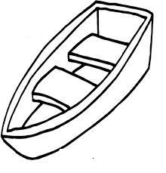

By road or by air, There is plenty to see, Gardens and plantations, Islands and animals.

Passengers from all over the world, With or without Luggage,
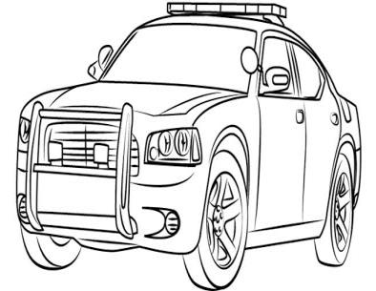

Pupils on their way to school,
Patients on their way to clinics, Tourist on their way to the zoo, And holiday makers of all races.

Travelling by train is fun,
As the engine pulls along “snake”
Wagons getting faster down the valley,
As passengers see the beautiful landscape, As they share experiences,
With the different people they meet.
Okello Isaac- P5
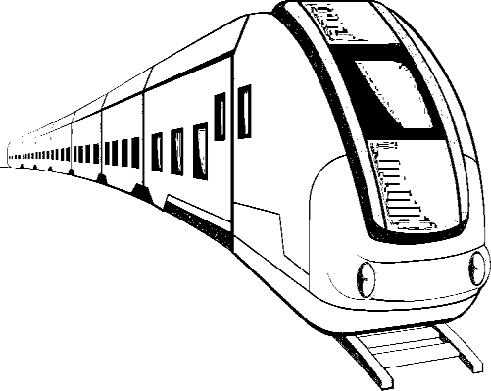

QUESTIONS

(a) Name one means of transport mentioned in the poem.

(b) What things are you able to see as you travel?

(c) Explain what the word “Passenger” means?
(d) Why does travelling interest the traveler more?

(e) Where does a tourist always go?

(f) Why is travelling by train best during the day?

(g) Name any one mean of transport used by passengers when travelling.

(h) What word means the same as “people walking on the road”?

(i) Suggest one reason why people travel.

(j) By whom was the poem written?

55. use the words in the table below to fill in blank spaces so as to make a meaningful story about newspaper

NEWS PAPERS
Timothy and Diana were wondering why father always reads different types of newspapers. They _to ask him. He told them that newspapers are written by different news reporters. Each
writes information different from the other. Some news reporters record Information in order to earn money from the public. Therefore, he reads different newspapers to compare .

Another why he reads different newspapers is that it enables him to get information on what is happening in Uganda and other parts of the
He wants to be informed, educated and entertained as some newspapers have interesting and exciting news items. He also
_them that he wants to get business _which are commonly advertised. After his clear _, the children thanked him and were encouraged to read newspapers too.

explanation | false | decided | their | opportunities
Journalist | told | notes | world | reason

